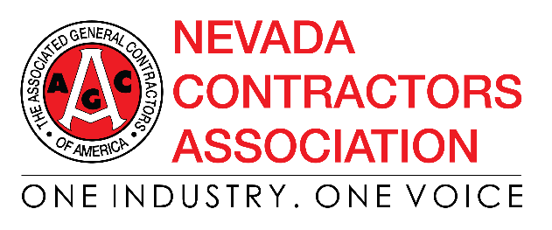
Proactive Measures for Addressing COVID-19
March 26, 2020

Pre-screening Questionnaire
Every construction project is unique and what is feasible and appropriate for any one project will depend on its unique characteristics. That said, the questions that construction contractors may want to ask of all employees, visitors and vendors, prior to allowing them to enter any one jobsite, include the following.
- Have you traveled to an area with known local or international spread of COVID-19 in the past 14 days? Yes No

- Have you, or anyone in your residence, come into close contact (within 6 feet) with someone who has a suspected or confirmed COVID – 19 diagnosis in the past 14 days either at home or on a jobsite, etc.?
Yes No

- Have you had a fever (greater than 100.4 F or 38.0 C) OR symptoms of lower respiratory illness such as cough, shortness of breath, or difficulty breathing in the past 14 days? Yes No

- Are you currently experiencing a fever (greater than 100.4 F or 38.0 C) OR symptoms of lower respiratory illness such as cough, shortness of breath, or difficulty breathing? Yes No
*NOTE: If an employee, visitor or vendor answer ‘Yes’ to any of the above questions, ask them to leave the workplace or jobsite immediately and seek medical evaluation. In addition, you should strongly consider following the tips below.

Preventing and Responding to a Suspected or Confirmed Positive Case of COVID-19
Prevention
If you have not had a suspected or confirmed case of COVID-19 in your workplace or on your jobsite, the additional steps that you may want to consider include the following.
- Implement a policy for early reporting of signs or symptoms of COVID-19. Doing so can assist with preventing the spread of the disease if the employee is a confirmed case.
  - If an employee displays signs or symptoms of COVID-19, immediately remove them from the workplace or jobsite.
- Educate your employees on how to protect themselves as outlined by CDC.
- Educate your employees on the signs and symptoms of COVID-19.
- Practice social distancing (maintaining a safe distance of at least six (6) feet from others) as much as practical.
- Require sick employees to stay at home.

Response
If you have a suspected or confirmed case of COVID-19, the additional steps that you may want to consider include these.
- Remove the infected, or potentially infected, employee from the workplace or jobsite: Before the employee departs, ensure you have a full list of affected employees who may need be sent home (i.e., individuals who worked in close proximity (three to six feet) with them in the previous 14 days). For suspected cases, take the same precautions and treat the situation as if the suspected case is a confirmed case for purposes of sending home potentially infected employees.

- Ensure a medical evaluation is completed: Advise the employee to contact a medical care provider to discuss the symptoms that they are experiencing and follow any orders given.

- Investigate: Just as you would investigate a workplace injury (i.e., slip and fall), investigate suspected or confirmed cases of COVID-19, and document your investigation. (Investigating may assist with the determination of work-relatedness of the confirmed case or exposure.)

COVID-19 can be a recordable illness if a worker is infected as a result of an event or exposure in the work environment. However, employers are only responsible for recording cases of COVID-19 if all of the following are met:
  - The case is a confirmed case of COVID-19 (see CDC information on persons under investigation and presumptive positive and laboratory-confirmed cases of COVID-19);
  - The case is work-related, as defined by 29 CFR 1904.5; and
  - The case involves one or more of the general recording criteria set forth in 29 CFR 1904.7 (e.g., medical treatment beyond first-aid, days away from work).

- Identify corrective actions: These items will include what additional measures could be put into place to prevent further spreading of the virus on the jobsite or in the workplace as well as future occurrences. Such measures may include the cleaning and sanitizing of the work area(s) and/or tools (hand and power) as well as reinforcing the guidelines for prevention outlined by CDC with others in the workplace and on the jobsite.

- Establish a procedure to follow up: Communicate with both affected and non-affected employees on the status of the suspected or confirmed COVID-19 case, but do not communicate the name of affected individuals or specific medical diagnoses. Where there is a confirmed case of COVID-19, notify affected employees and encourage them to seek medical attention. If a suspected case tests negative, notify affected employees and encourage them to return to work.

