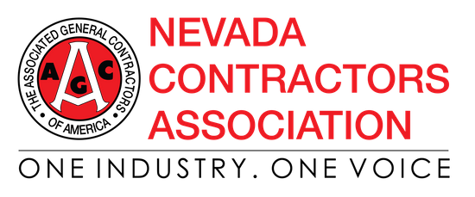
CORONAVIRUS (COVID-19) INFORMATION (page 1)
NCA SAFETY TOOLBOX TALK

What is a Coronavirus?
Coronaviruses are a family of viruses that can cause respiratory illness in people. Coronaviruses circulate amongst animals, including camels, cattle, cats, and bats.

How is the Novel Coronavirus, COVID-19 Different from Other Coronaviruses?
Just like there are different types of related viruses that cause smallpox, chickenpox, and monkeypox, different coronaviruses cause different diseases in people. The Severe Acute Respiratory Syndrome (SARS) coronavirus causes SARS and the Middle East Respiratory Syndrome (MERS) coronavirus causes MERS. The novel coronavirus, COVID-19 is one of seven types of known human coronaviruses. COVID-19, like the MERS and SARS coronaviruses, likely evolved from a virus previously found in animals. The remaining known coronaviruses cause a significant percentage of colds in adults and children, and these are not a serious threat for otherwise healthy adults.

What are the Signs and Symptoms of COVID-19 infection?
Patients with confirmed COVID-19 infection have reportedly had mild to severe respiratory illness with symptoms such as fever, cough, and shortness of breath.

What Should I Do if I Think I Have Been Exposed to or Infected with COVID-19?
Alert your healthcare provider immediately if you think you may be infected with COVID-19, including if you have been exposed to someone with the virus and have signs/symptoms of infection. If you are experiencing symptoms, you should tell your healthcare provider about any recent travel to areas where COVID-19 is spreading. If you believe you have been exposed on the job, alert your supervisor or occupational health clinic immediately.

How is COVID-19 Diagnosed?
Your healthcare provider can determine if your signs and symptoms are explained by other causes, or if there is reason to suspect you may have COVID-19. If laboratory testing is appropriate, your healthcare provider will work with health officials in your state, who in turn will work with the CDC to collect and test any clinical specimens for a proper diagnosis.

How is COVID-19 Treated?
No vaccine or specific treatment for COVID-19 infection is available. Hospitals can provide supportive care for infected people.

*The above information is from The Occupational Safety and Health Administration (OSHA).

There is currently no vaccine to prevent coronavirus disease 2019 (COVID-19). The best way to prevent illness is to avoid being exposed to this virus. The following is from the Centers for Disease Control and Prevention (CDC).
CORONAVIRUS (COVID-19) INFORMATION (page 2)
NCA SAFETY TOOLBOX TALK

The virus is thought to spread mainly from person-to-person:
- Between people who are in close contact with one another (within about 6 feet).
- Through respiratory droplets produced when an infected person coughs or sneezes. These droplets can land in the mouths or noses of people who are nearby or possibly be inhaled into the lungs.

Older adults and people who have severe underlying chronic medical conditions like heart or lung disease or diabetes seem to be at higher risk for developing more serious complications from COVID-19 illness.
Please consult with your health care provider about additional steps you may be able to take to protect yourself.

Take steps to protect yourself:

Clean your hands often
- Wash your hands often with soap and water for at least 20 seconds, especially after you have been in a public place or after blowing your nose, coughing, or sneezing.
- If soap and water are not readily available, use a hand sanitizer that contains at least 60% alcohol. Cover all surfaces of your hands and rub them together until they feel dry.
- Avoid touching your eyes, nose, and mouth with unwashed hands.

Avoid close contact
- Avoid close contact with people who are sick
- Put distance between yourself and other people if COVID-19 is spreading in your community. This is especially important for people who are at higher risk of getting sick.

Take steps to protect others
- Stay home if you are sick, except to get medical care.

Cover coughs and sneezes
- Cover your mouth and nose with a tissue when you cough or sneeze or use the inside of your elbow.
- Throw used tissues in the trash.
- Immediately wash your hands with soap and water for at least 20 seconds. If soap and water are not
readily available, clean your hands with a hand sanitizer that contains at least 60% alcohol.

Wear a facemask if you are sick
- If you are sick: You should wear a facemask when you are around other people (e.g., sharing a room or vehicle) and before you enter a healthcare provider’s office. If you are not able to wear a facemask (for example, because it causes trouble breathing), then you should do your best to cover your coughs and sneezes, and people who are caring for you should wear a facemask if they enter your room.

CORONAVIRUS (COVID-19) INFORMATION (page 3)
NCA SAFETY TOOLBOX TALK

- If you are NOT sick: You do not need to wear a facemask unless you are caring for someone who is sick (and they are not able to wear a facemask). Facemasks may be in short supply and they should be saved for caregivers.

Clean and disinfect
- Clean AND disinfect frequently touched surfaces daily. This includes tables, doorknobs, light switches, countertops, handles, desks, phones, keyboards, toilets, faucets, and sinks.
- If surfaces are dirty, clean them: Use detergent or soap and water prior to disinfection.
- To disinfect: Most common EPA-registered household disinfectants will work. Use disinfectants appropriate for the surface.

Disinfectant options include:
- Diluting your household bleach. To make a bleach solution, mix:
  - 5 tablespoons (1/3rd cup) bleach per gallon of water OR
  - 4 teaspoons bleach per quart of water
  - Follow manufacturer’s instructions for application and proper ventilation. Check to ensure the product is not past its expiration date. Never mix household bleach with ammonia or any other cleanser. Unexpired household bleach will be effective against coronaviruses when properly
diluted.

Alcohol solutions.
  - Ensure solution has at least 70% alcohol.

Other common EPA-registered household disinfectants.
  - Products with EPA-approved emerging viral pathogens claims are expected to be effective against
COVID-19 based on data for harder to kill viruses. Follow the manufacturer’s instructions for all cleaning and disinfection products (e.g., concentration, application method and contact time,
etc.).

Links to Resources:
- Centers for Disease Control and Prevention (CDC): https://www.cdc.gov/
- Occupational Safety and Health Administration: https://www.osha.gov/
- World Health Organization: https://www.who.int/emergencies/diseases/novel-coronavirus-2019

De DEALING WITH CORONAVIRUS ON CONSTRUCTION JOBSITES
NCA SAFETY UPDATE

In response to concerns about the spread of the coronavirus (COVID-19), the NCA is providing employers with guidance on how to ensure workers’ safety on jobsites. These suggested policies and procedures for limited exposure to coronavirus address issues specific to construction jobsites. Many construction jobsites lack the same facilities of other workplaces and can contain challenges to hygiene and other suggested protocols.

Supply portable washing stations or hand sanitizers for workers. Frequent hand washing is one of the best ways to protect workers from exposure. Many projects, however, have limited access to running water. Portable stations with water containers should be placed on site to allow workers to wash their hands frequently. Portable stations can be rented from local suppliers or created by workers. In areas where portable stations are not practical, supply hand sanitizer for workers. Hand sanitizers should contain at least 60% alcohol.

Separate construction workers from occupied building workers. To reduce exposure to possibly exposed or infected persons, implement procedures for minimizing contact between workers that don’t usually work together. This may be a problem for jobsites where workers are in occupied buildings. Review with workers policies to keep them safe from exposure. Some policies may include separate bathroom facilities, isolating workers lunch and break areas, and limiting interactions with building employees.

Implementing these measures on your jobsite may help reduce the spread of exposure to the coronavirus.
Taking these actions will also reinforce to workers that measures are being taken to ensure their safety. We need to work together to reduce opportunities of exposure for all workers.

Provide training and toolbox talks for workforce. Information is the key to protecting workers. Discuss with employees the hazards associated with coronavirus. Use informational bulletins circulated by the Centers for Disease Control (CDC), the Occupational Safety and Health Administration (OSHA), and the World Health Organization (WHO). Reference information from reputable sources, as some information you may find on the internet may be misleading or wrong.

Disinfect high traffic areas frequently. For areas of high use, use disinfectants to keep areas clean. Job trailer doors and stair rails, meeting tables, and coffee stations should all be frequently cleaned using a bleach-based cleaner.

Be defensive during interactions with others. During this period of uncertainty, monitor yourself and others and pay special attention to limit social contact with others. Train yourself to not cross-contaminate or to touch your face. Share respect, not potentially harmful germs.
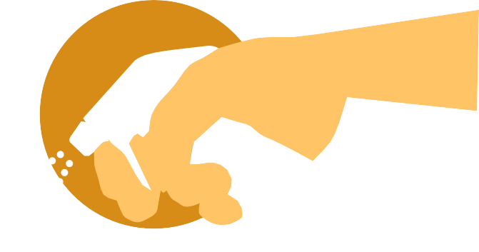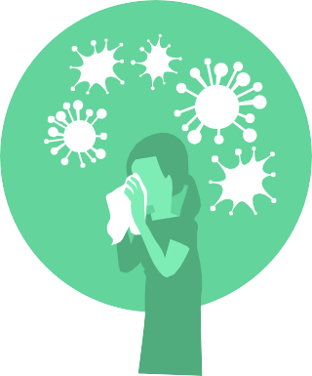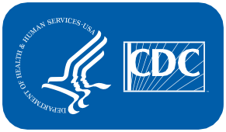 STOP THE SPREAD OF GERMS

Help prevent the spread of respiratory diseases like COVID-19.

Cover your cough or sneeze with a tissue, then throw the tissue
Avoid close contact with people who are sick.
in the trash.

Clean and disinfect frequently touched objects and surfaces.

Avoid touching your eyes, nose, and mouth.

Stay home when you are sick, except to get medical care.

Wash your hands often with soap and water for at least 20 seconds.

For more information: www.cdc.gov/COVID19

CS314915-A

Stop Germs! Wash Your Hands.

When?
- After using the bathroom
- Before, during, and after preparing food
- Before eating food
- Before and after caring for someone at home who is sick with vomiting or diarrhea
- After changing diapers or cleaning up a child who has used the toilet
- After blowing your nose, coughing, or sneezing
- After touching an animal, animal feed, or animal waste
- After handling pet food or pet treats
- After touching garbage

How?

Wet your hands with clean, running water (warm or cold), turn off the tap, and apply soap.
Lather your hands by rubbing them together with the soap.
Be sure to lather the backs of your hands, between
Scrub your hands for at least 20 seconds.
Need a timer? Hum the “Happy Birthday” song from beginning
Rinse hands well under clean, running water.
Dry hands using a clean towel or air dry them.

your fingers, and
under your nails.
to end twice.

Keeping hands clean is one of the most
important things we can do to stop the spread of germs and stay healthy.

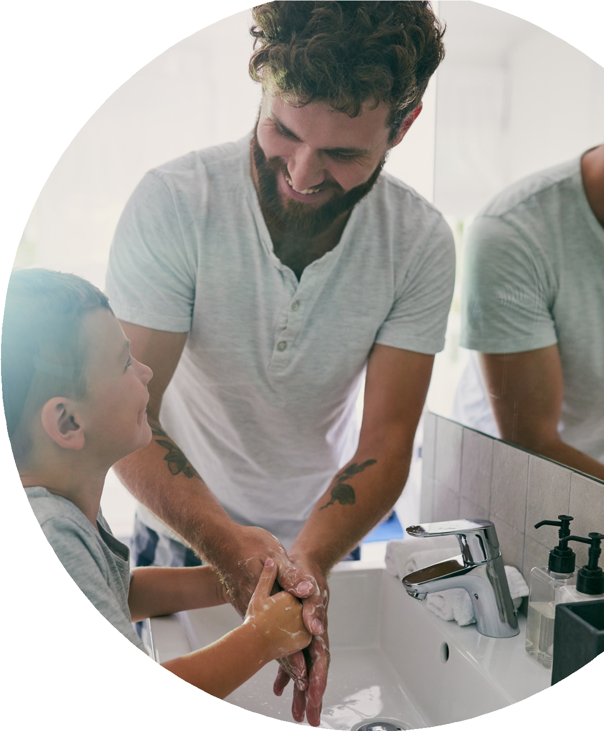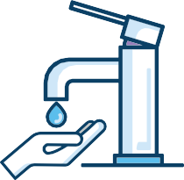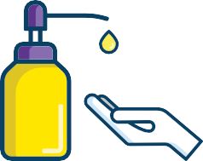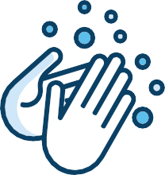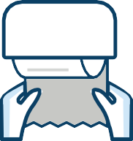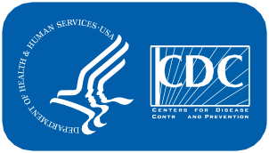

www.cdc.gov/handwashing
This material was developed by CDC. The Life is Better with Clean Hands Campaign is made possible by a partnership between the
CDC Foundation, GOJO, and Staples. HHS/CDC does not endorse commercial products, services, or companies. CS310027-A

